**Petoskey Area Garden Club**

**~ 2024 Gardens ~**

Landscape Maintenance Report August 3, 2024

The first week of August could be classified as the “Dog Days of Summer” hot and sultry. As the madness of July has come to an end, we should ponder what we would like our gardens to look like in 2025. I am a visual person so hopefully the weekly garden reports with the pictures help to identify what is working and is not for you and your team.

**1. Garden**: Bayfront Park/Waterfall

**Bed Captain**: Kari Solomon

The beds are being well maintained. This is the second year that the impatiens looks less than stellar. Hopefully we can come up with something to replace them in 2025. One of the trees in the waterfall bed is looking unwell. We need to check with John Hummel about that. We may have to consider spending some time and money to bring a more cohesiveness to the three garden areas.

**2. Garden**: History Museum

**Bed Captain**: Connie Lenau

Great teamwork keeping the History Museum looking wonderful. The “Night at the Museum” Corn Roast is August 16, 2024, 5-830pm tickets $20. **This is the night for the garden to SHINE!**

**3. Garden**: Pennsylvania Park

**Bed Captain**: Pam Washburn

The gazebo pots are in full bloom and center of attention every Wednesday and Friday 12-1pm for the Charlottee Ross Lee concerts through August 16th.

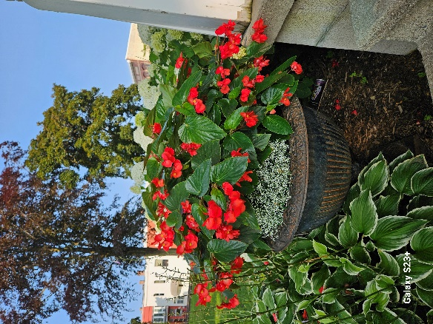

**4. Garden**: City Center

**Bed Captain**: Sharon Schappacher

The center city bed is doing well considering all the construction going on around it. The

Hostas would benefit from some bug spray. The verbena could use some deadheading to promote more growth before the season ends.

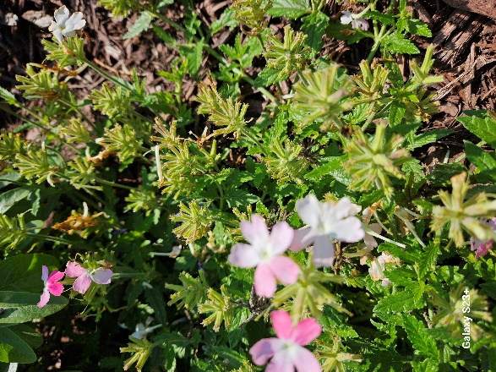

**5. Garden**: Gaslight District

**Bed Captain**: Ethel Larsen

The marigolds are looking happy this week. I would consider adding a couple of flats next year to give it a fuller look. The begonias seem to like the full sun this garden gets. The silva not so much.

**6. Garden**: South bed - Mitchell Street

**Bed Captain**: Marjorie Green

The hydrangeas are in full bloom for the motorist to see. The petunias seem to be struggling along. From a distance they look okay. I would consider trying something different that would complement the begonias and coleus. The other gardens that have petunias are faring well so maybe they don’t like all the traffic noise!

**7. Garden**: Mitchell Street Bridge baskets

**Bed Captain**: Jane Bock

I’m surprised that we don’t have a few fender benders on the bridge as people admire the stunning petunia baskets this year. Thanks to John Hummel for keeping them healthy.

**8. Garden**: Library pots

**Bed Captains**: Kathleen Davis & Kari Solomon

The library saw some changes with the new pots and placement this season. The two urns with dragon wing begonias at the main entrance leave quit the mess. The pot on the side door is a great size for the area but needs updating and maybe try something different in that pot as well. The 2 pots off Waukazoo need to be larger for the space. The dragon wing begonias like the open sunny spot and don’t leave such a mess. The butterfly was on the butterfly bush that the PAGC donated to the library a while ago.

**9. Garden**: Monarch Way Station

**Bed Captains**: Sharon Walker

It’s always an adventure to get to the Monarch Way Station. It’s like walking in an enchanted forest. I think the PGC should spend some money here as well in 2025. There are a lot of people who commute into the city on the river path. It would be nice to add some color. I’m sure the members who tend that garden might like to see something other than green! Bret Huntsman’s presentation at our last meeting might give us some ideas like utilizing the Homegrown National Park website that has a native plants finder. Attached is a link to the homegrown national park website. https://homegrownnationalpark.org/

Report written by: Kari Solomon August 3, 2024

Submitted by Kari Solomon and Kathleen Davis

Landscape Maintenance co-chairs PAGC